- Copyright for test papers and marking guides remains with West Australian Test Papers.
- The papers may only be reproduced within the purchasing school according to the advertised conditions of sale.
- Test papers must be withdrawn after use and stored securely in the school until Friday 15th June 2018.



CHEMISTRY
UNIT 1
2018

MARKING GUIDE

Section One: Multiple-choice (50 marks)

1 | a □ b □ c □ d ■ |  | 11 | a □ b □ c ■ d □ |  | 21 | a □ b □ c □ d ■
2 | a ■ b □ c □ d □ |  | 12 | a □ b □ c ■ d □ |  | 22 | a ■ b □ c □ d □
3 | a □ b □ c □ d ■ |  | 13 | a ■ b □ c □ d □ |  | 23 | a □ b ■ c □ d □
4 | a □ b □ c ■ d □ |  | 14 | a □ b □ c ■ d □ |  | 24 | a □ b □ c ■ d □
5 | a □ b □ c ■ d □ |  | 15 | a □ b ■ c □ d □ |  | 25 | a □ b ■ c □ d □

6 | a □ b □ c □ d ■ |  | 16 | a □ b □ c □ d ■
7 | a □ b ■ c □ d □ |  | 17 | a ■ b □ c □ d □
8 | a □ b ■ c □ d □ |  | 18 | a □ b □ c □ d ■ |  |  | (2 marks per question)
9 | a □ b □ c □ d ■ |  | 19 | a ■ b □ c □ d □
10 | a ■ b □ c □ d □ |  | 20 | a □ b □ c ■ d □

Section Two: Short answer 35% (70 marks)

This section has 10 questions. Answer all questions. Write your answers in the spaces provided.

When calculating numerical answers, show your working or reasoning clearly. Express numerical answers to the appropriate number of significant figures and include appropriate units where applicable.

Spare pages are included at the end of this booklet. They can be used for planning your responses and/or as additional space if required to continue an answer.
- Planning: If you use the spare pages for planning, indicate this clearly at the top of the page.
- Continuing an answer: If you need to use the space to continue an answer, indicate in the original answer space where the answer is continued, i.e. give the page number. Fill in the number of the question(s) that you are continuing to answer at the top of the page.

Suggested working time: 60 minutes.

Question 26 (6 marks)

Two sulfur-containing compounds that have very different properties are aluminium sulfate (Al₂(SO₄)₃) and sulfuric acid (H₂SO₄). Explain, in terms of structure and bonding, why aluminium sulfate is a solid at room temperature, whereas pure sulfuric acid is an oily liquid.

- aluminium sulfate is ionic
- strong electrostatic attraction between the cations and anions form rigid lattice
- large amount of heat required to disrupt the bonding, so melting point is high and therefore solid at room temperature

- sulfuric acid is covalent molecular
- therefore there are only weak intermolecular forces between discrete molecules
- so much less heat is required to disrupt the bonding, so melting point is lower than room temperature, therefore a liquid

Question 27 (8 marks)

(a) Complete the table below by; (6 marks)
- drawing structural formulas showing all bonds and atoms, and
- writing the molecular formula for each organic molecule.

 | Structural diagram | Molecular formula
2,2,3-trimethylbutane | 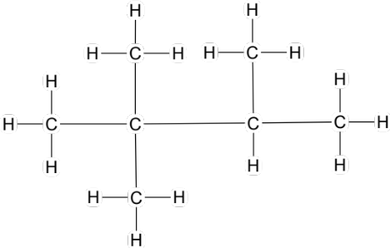 | C₇H₁₆
3-ethylpent-2-ene | 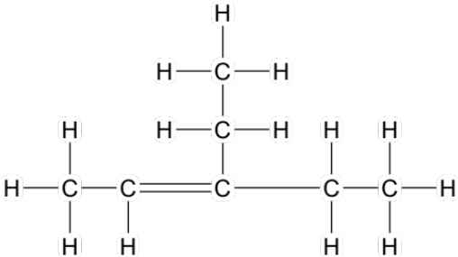 | C₇H₁₄
methylbenzene | 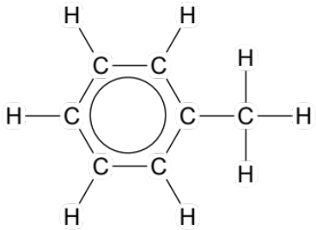 | C₇H₈

Question 28 (8 marks)

Consider the elements labelled A-E on the diagram below, which shows the first four periods of the periodic table.

A
 | B |  |  |  |  |  |  |  |  |  |  |  |  |  | C | D
E

(a) Why are A and E both in group 1? (1 mark)

- both have one valence electron

(b) Why are B, C and D all in period 2? (1 mark)

- all have electrons filling the second shell

(c) Why would atoms of element C and E form chemical bonds? State the type of compound formed and describe how the chemical bonds form. (3 marks)

- By bonding, both elements would achieve a full, stable octet (E₂C or Na₂O)
- Ionic bonds / ionic compound would form
- E (sodium, 1 valence electrons) would donate electrons to C (oxygen, 6 valence electrons)

(d) Why would atoms of element C and D form chemical bonds? State the type of compound formed and describe how the chemical bonds form. (3 marks)

- By bonding, both elements would achieve a full, stable octet (D₂C / CD₂ or OF₂ / F₂O)
- Covalent compound / covalent molecule / covalent bonds would form
- C (oxygen, 6 valence electrons) and D (fluorine, 7 valence electrons) would share electrons

Question 29 (6 marks)

Consider the diagram below.

melting boiling

H₂O(s) H₂O(l) H₂O(g)

solidification condensation

(a) Name one (1) of the labelled phase changes that is endothermic. Justify your choice. (3 marks)
- melting OR boiling
- both processes require an input of heat (this increases both Ek and Ep) / in both processes product has greater energy/enthalpy than reactant
- therefore ΔH is positive and reaction is endothermic

Bioluminescent Bay in Puerto Rico is a popular tourist attraction because of the microorganisms that live in the water. These types of organisms glow in the dark because they produce light by a special chemical reaction.

(b) Explain why this reaction is exothermic. (3 marks)

- production of light by a chemical reaction means energy is released from system
- therefore enthalpy of products lower than enthalpy of reactants
- therefore ΔH is negative and reaction is exothermic

Question 30 (8 marks)

All matter can be classified as either pure substances or mixtures.

(a) Complete the table below by writing the name or formula of the compound, as well as classifying the compound as having consistent properties with either an ionic or covalent substance. (6 marks)

Name | Formula | Covalent or ionic bonding
Ammonium carbonate | (NH₄)₂CO₃ | ionic
Iron(III) nitrate | Fe(NO₃)₃ | ionic
Ethanoic acid | CH₃COOH | covalent

The table above refers only to pure substances.

(b) State two (2) ways a mixture differs from a pure substance. (2 marks)

- mixture has no fixed composition, no formula, variable properties, can more easily be separated, contains 2 or more different substances… any 2 relevant points

Question 31 (7 marks)

Complete the table below, showing the subatomic particle arrangement of the four different species.

Symbol | Number of protons | Number of neutrons | Electron configuration
¹⁹F | 9 | 10 | 2, 7
²³Na⁺ | 11 | 12 | 2, 8
³²S²⁻ | 16 | 16 | 2, 8, 8
¹⁴C | 6 | 8 | 2, 4
Question 32 (7 marks)

Salts containing the metal potassium (K) have a characteristic lilac (purple) colour in a flame test. A chemistry student was planning on performing flame tests on a series of different salt samples, trying to find one that contained a rare isotope of potassium. However, the student decided that the flame test would not be reliable as the isotope flame colour would be different from usual.

(a) What is an isotope? (2 marks)

- atoms of an element that have the same number of protons but different numbers of neutrons
- atoms with the same atomic number but different mass number
- resulting in similar chemical properties but different physical properties

… any 2 of these relevant points

(b) Was the student correct? Explain. (3 marks)

- no
- flame tests depend on movement of electrons
- isotopes of potassium have the same number of electrons / same electron configuration, so flame test would give same result

The relative atomic mass (Ar) of potassium is 39.10.

(c) What is the Ar of an element? What does it indicate that the Ar of potassium is close to the whole number of 39? (2 marks)

- weighted average mass of all known isotopes of an element / average mass of an atom compared to 1/12th the mass of a C-12 / average mass of an atom, weighted by abundance of all known isotopes
- major isotope / most abundant isotope of potassium likely to be K-39

Question 33 (9 marks)

Nanosilver is an example of a nanomaterial and refers to an extremely finely divided form of silver. Nanosilver is used widely due to its ability to function as an antibiotic and disinfectant.

(a) What is a nanomaterial? (2 marks)

- materials containing particles between 1-100 nm in size
- properties of these nanomaterials often differ from the properties of the bulk material

(b) Name one other nanomaterial and list two uses it has (3 marks)

- nanogold
- treatment of malaria, cancer, used in art etc (any reasonable uses)

Despite its beneficial qualities, there may be potential dangers from nanoparticles.

(b) Explain two potential dangers (2 marks)

- not sure of side effects, relatively new tech, small size can move into cells, unknown risks, damage might be caused, side effects unknown… any 2 relevant points

It is thought that the antibacterial properties of nanosilver occur when silver ions (Ag⁺) are released by the silver nanoparticles.

(c) What is an ion? Explain how a silver ion forms. (3 marks)

- an ion is a charged particle
- formed due to the gain or loss of electron(s)
- Ag loses one electron to form Ag⁺ ions, giving it an overall positive charge since the number of protons is now 1 more than the number of electrons

A nurse used a bandage coated with 0.0837 g of nanosilver to cover a serious burn on a patient’s arm and prevent it becoming infected.

(d) Calculate the number of atoms of silver present on the bandage. (2 marks)

n(Ag) = m/M
= 0.0837 / 107.9
= 7.75718 x 10⁻⁴ mol

N(Ag) = n x Av
= 7.75718 x 10⁻⁴ x 6.022 x 10²³
= 4.67 x 10²⁰ atoms

Question 34 (5 marks)

Complete the reactions below by drawing structural formulas or naming the substances as required.

(a)
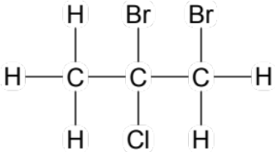
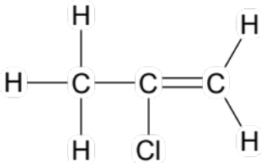
Name:
2-chloropropene
+Br₂ →
Name:
1,2-dibromo-2-chloropropane
Structural formula:

(b)
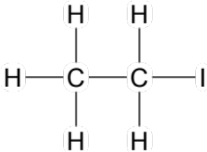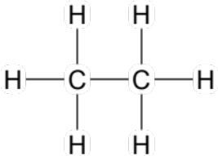
Name:

iodoethane
Formula:

HI
+I₂ → +

Section Three: Extended answer 40% (80 marks)

This section contains five (5) questions. You must answer all questions. Write your answers in the spaces provided below.

Where questions require an explanation and/or description, marks are awarded for the relevant chemical content and also for coherence and clarity of expression. Lists or dot points are unlikely to gain full marks.

Final answers to calculations should be expressed to the appropriate number of significant figures.

Spare pages are included at the end of this booklet. They can be used for planning your responses and/or as additional space if required to continue an answer.
- Planning: If you use the spare pages for planning, indicate this clearly at the top of the page.
- Continuing an answer: If you need to use the space to continue an answer, indicate in the original answer space where the answer is continued, i.e. give the page number. Fill in the number of the question(s) that you are continuing to answer at the top of the page.

Suggested working time: 70 minutes.

Question 36 (14 marks)

Study the following diagram of a torch (flashlight). Several components have been labelled and some information about the properties of these materials has also been included.

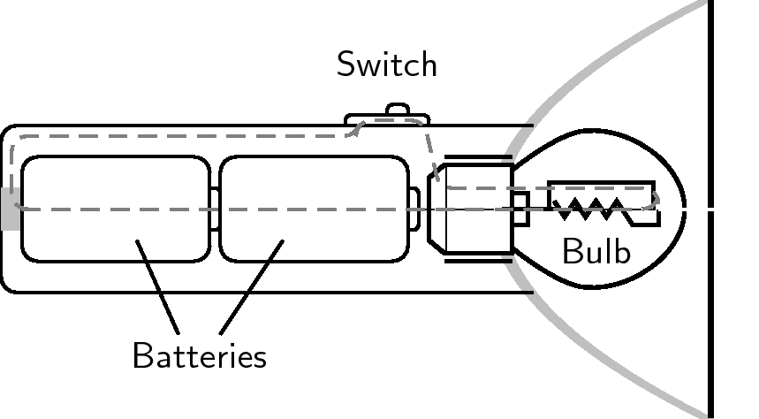
Ammonium chloride (NH₄Cl) paste
- used as a component in batteries because it conducts electricity.
Glass / Silicon dioxide (SiO₂)
- used to protect the bulb because it is hard and strong.
Plastic ((C₂H₄)_{x})
- used to make the body of the torch because it is a soft substance that can be shaped easily.
Copper (Cu)
- used for the wiring because it is malleable and conducts electricity.

Explain why each of the labelled materials has been used in this torch. Your answer should focus on the type of bonding present in each of the four (4) labelled components, as well as an explanation of their main properties (shown in bold), in terms of the structure and bonding present.

For (C₂H₄)_{x}
- covalent molecular
- weak intermolecular forces between discrete molecules
- small force required to change the shape of the solid / can be easily moulded without breaking intermolecular forces

For SiO₂
- covalent network
- strong covalent bonding throughout entire 3D network
- a large amount of force is required to disrupt to disrupt the covalent bonds, therefore hard and strong

For Cu
- metallic
- sea of delocalised electrons throughout
- mobile charged particles present (delocalised electrons) allow it to conduct electricity
- non-directional bonding
- force can be applied without breaking bonds / force can be applied to cause substance to change shape, therefore ductile

For NH₄Cl
- ionic
- ions dissociate because it is paste / wet / (aq)
- mobile charged particles present (ions) allow it to conduct electricity

Question 38 (19 marks)

Three groups of chemistry students (A, B and C) were investigating exothermic and endothermic reactions. Each group was given one reaction to study, as shown in the table below.

Group A | HCl(aq) + NaHCO₃(aq) → NaCl(aq) + CO₂(g) + H₂O(l)
Group B | CuSO₄(aq) + Mg(s) → MgSO₄(aq) + Cu(s)
Group C | Ba(OH)₂(s) + 2 NH₄SCN(s) → Ba(SCN)₂(aq) + 2 H₂O(l) + 2 NH₃(g)

Each group planned their experiment, with the aim to investigate whether their reaction was exothermic or endothermic. They mixed their reagents together in test tubes and recorded the initial temperature of the system, as well as the final temperature once the reaction was finished.

The incomplete results of each group are shown in the tables below.

Group A | Trial 1 | Trial 2 | Trial 3
Initial temp (°C) | 20.5 | 20.0 | 21.5
Final temp (°C) | 17.0 | 16.0 | 18.0
Temperature change (°C) | - 3.5 | - 4.0 | - 3.5

Group B | Trial 1 | Trial 2 | Trial 3
Initial temp (°C) | 22.5 | 21.5 | 23.0
Final temp (°C) | 25.0 | 26.5 | 26.5
Temperature change (°C) | + 2.5 | + 5.0 | + 3.5

Group C | Trial 1 | Trial 2 | Trial 3
Initial temp (°C) | 18.5 | 19.0 | 19.5
Final temp (°C) | 4.0 | 5.5 | 3.5
Temperature change (°C) | -14.5 | - 13.5 | - 16

The final temperature reading of group C is shown on the thermometer to the right.
15
10
5
0
-5
-10
-15

(a) Complete the tables on the previous page, by reading the final result for group C and recording it in the correct table. Then fill in any other values that are missing, by calculating the change in temperature (i.e. final – initial). (4 marks)

(1) complete group A
(1) complete group B
(1) read thermometer accurately for last group C value
(1) complete group C

The following diagrams represent the energy changes that can occur during a reaction, as well as illustrate whether a reaction is endothermic or exothermic.

Diagram X Diagram Y
Reactants
Products
H
Progress of reaction
Reactants
Products
H
Progress of reaction

Choose one of the reactions investigated (A, B or C) that corresponds to Diagram X.

(b) State the reaction (A, B or C) and explain what information this diagram provides in terms of the bond breaking and bond making that has occurred in your chosen reaction. (3 marks)

- B, because the temperature increased
- This corresponds to Diagram X which represents an exothermic reaction
- This means that the energy required to break the bonds (in the reactants) was less than the energy released when the new bonds (between the products) formed

Choose one of the reactions investigated (A, B or C) that corresponds to Diagram Y.

(c) State the reaction (A, B or C) and explain why this diagram represents your chosen reaction. Include a description of how the Law of Conservation of Energy relates to this diagram. (4 marks)

- A or C, because the temperature decreased
- Diagram Y is an endothermic reaction, showing that heat has been taken in from the surroundings
- This heat has been converted to enthalpy, so the enthalpy of P > R
- This upholds the Law of Conservation of Energy because energy has not been created or destroyed, only converted from one form to another (heat to enthalpy)

(d) Explain why the groups would have chosen to carry out three trials. (2 marks)

- so they could calculate an average
- minimise the effects of random error
- greater reliability of data / results
… any 2 correct statements

(e) Which group had the most precise results? Justify your answer and explain the difference between precise and accurate. (3 marks)

- Group A has the most precise
- They had the smallest range in their results

- Precise values are close together, accurate values are close to the actual / theoretically correct value

Group B realised that they had forgotten to ‘tare’ (reset to zero) the balance they used to weigh out the magnesium metal. This resulted in them using less Mg(s) than intended in each trial.

(f) Is this a random or systematic error? Justify your choice and state the likely effect that this error would have had on the final temperatures that group B measured (i.e. higher, lower or unchanged)? (3 marks)

- systematic
- this type of error can be minimised by using correct scientific technique (i.e. taring the balance) / this type of error causes consistently high or low measurements to be made (i.e. affects all measurements similarly)

- final temp measured would likely be lower than if more Mg had been used (as this is an exothermic reaction, you could assume a larger amount of Mg would have allowed the reaction to proceed further and therefore produce more heat)

Question 39 (19 marks)

Diesel is a fuel that can be obtained from crude oil. It is used in most forms of transport, from trucks, cars and tractors to aircraft and rail cars. Biodiesel is most commonly produced from vegetable oil in a chemical reaction called transesterification. It can be used in pure form, in many of the same vehicles as regular diesel, however it is often used as a biodiesel-diesel mix.

(a) Briefly describe two (2) advantages of using biofuels instead of fossil fuels as an energy source. (2 marks)

- use renewable resources rather than non-renewable, lower overall CO₂ emissions, decreased environmental impact such as global warming / polar ice caps melting / ocean acidification, more sustainable process… any 2 relevant points

(b) State two (2) reasons it is not always possible for people to use biofuels. (2 marks)

- not available to lots of people / countries / places in the world, expensive, new technology / processes not developed properly yet, not available on large enough scale for general public… any 2 relevant points

(c) Ethanol in and example of a biofuel that is described as being ‘carbon neutral”. Explain what is meant by this expression. (2 marks)

- There are no net carbon dioxide emissions.
- The carbon dioxide released into the atmosphere when burnt, is equal to the carbon dioxide that is removed from the atmosphere during growth of the plants that are used to make ethanol.

(d) Suggest two reasons whey most people have not switched to using ethanol powered cars. (2 marks)
- Not widely available.
- Expensive
- Does not store as much energy as petrol.
- May cause damage to a petrol engine

(e) Biodiesel produces much less sulphur dioxide then it is burned than normal diesel does. Explain why this is an advantage. (2 marks)

- Sulfur dioxide can cause acid rain/ smog so a
- fuel that produces less sulfur dioxide will be better for the environment

(f) Explain one positive and one negative effect of producing biodeiesel (2 marks)

Positive: e.g. Growing crops for biodiesel is labour intensive , so provides jobs for local people (1 mark).
Negative: e.g. If there is increased demand for biodiesel, farmers may switch to growing crops for biodiesel and fewer crops will be grown for food , so food will become more expensive (1 mark).

Question 40 (13 marks)

Meteorites that hit the Earth’s surface can provide scientists with information about the chemical composition of objects in different parts of our solar system or galaxy. A sample of ice was taken from a meteorite that landed in the Australian outback, and the extra-terrestrial water was analysed to determine the presence of various elements.

Atomic absorption spectroscopy (AAS) was used to determine the presence and concentration of various elements in the extra-terrestrial water, including silicon. AAS is an effective technique because each element has it’s own characteristic absorption / emission spectrum.

(a) Explain how electron absorption / emission spectra are related to the electron shells (levels) of an element. (4 marks)

- electron shells have specific energy levels / electrons shells have energy levels unique to each element
- electrons can move between electron shells by absorbing or emitting specific amounts of energy / each element has different energy change possibilities
- these amounts of energy have particular frequencies / the energy changes of electrons depends on the electron configuration
- this corresponds to and is visualised by an emission or absorption spectrum

AAS determined that there was some silicon present in the extra-terrestrial water. Some of the silicon sample was isolated and sent for analysis by mass spectrometry, to determine if the isotopic forms of this silicon were the same as those found on Earth.
The results of the mass spectrometry are shown below.

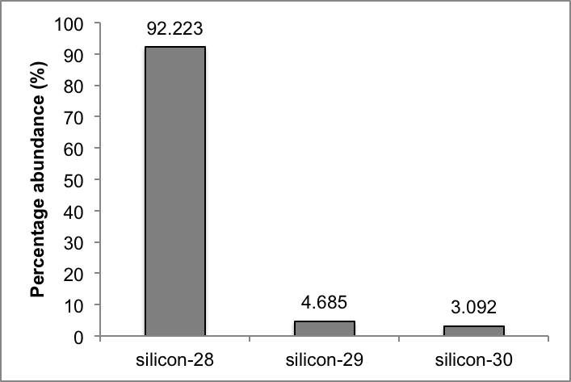
(b) Calculate the relative atomic mass (Ar) of this extra-terrestrial silicon, and comment on its similarity to the silicon found on Earth. (3 marks)

Ar = ( 92.223 x 28 + 4.685 x 29 + 3.092 x 30 ) / 100

= 28.109

Slightly higher than Earth silicon (28.09)

A portion of the periodic table, showing the elements surrounding silicon, is given below. Consider the five elements in the diagram.

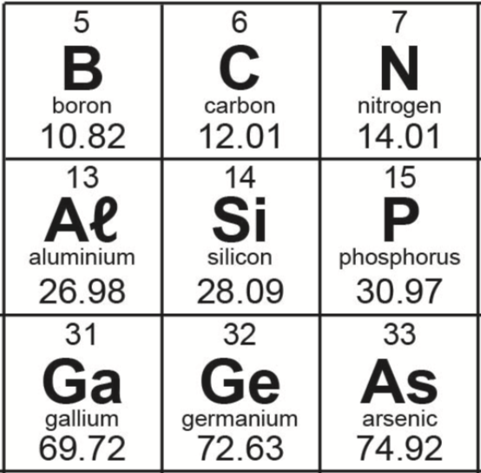

(c) Of these elements, germanium has the largest atomic radius and the smallest first ionisation energy. Explain why. (3 marks)

- largest atomic radius because greatest number of electron shells filled

- lowest 1st ionisation energy because outermost electron is furthest from nucleus
- therefore requires lowest/smallest amount of energy to remove (also shielding of inner shells)

(d) Define electronegativity, and state and explain the trend in electronegativity as you move left to right from aluminium to phosphorus. (3 marks)

- electronegativity is measure of how strongly an atom attracts a bonding pair of electrons towards itself
- electronegativity increases from aluminium to phosphorus (i.e. across a period)
- this is because across a period the atomic radius decreases and the core charge increases, therefore the pull on an electron becomes stronger

End of questions

